내용

1. Procedure 2

2. Intro 3

3. Register 4

4. Register-Personal 5

5. Register-Security 6

6. Register-Upload 7

7. Register-PennyTest 8

# Procedure

**Register-PennyTest**

**Login (Possible)**

**Intro**

**Register**

**Register-Upload**

**Register-Security**

**Register-Personal**

# Intro

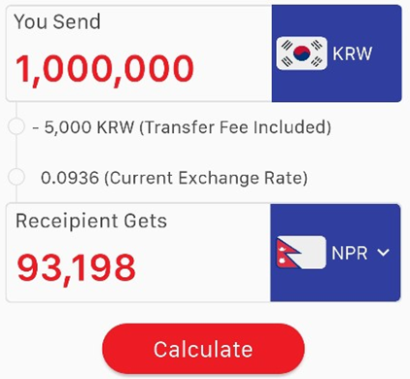

New User

Login

Select Language

|  |  |
| --- | --- |
| Select Language |  |
| Calculate |  |
| Login |  |
| New User |  |
|  |  |
|  |  |
|  |  |
|  |  |

# Register

Register to Global Money Express

Country

ID

Password

Mobile-Number

Next

|  |  |
| --- | --- |
| ID | Minimum 4 characters (number, character)  Don’t Duplicate ID |
| Password | Minimum 6 characters (number, character, special chatacter) |
| Country |  |
| Mobile-Number | Copy & Paste Possible |
| Next |  |
|  |  |
|  |  |
|  |  |

# Register-Personal

Tell us a few things about yourself

Full Name

Email Address

Select Gender

Address in Korea

Select City

Select Occupation

Referral Code (Optional)

Next

|  |  |
| --- | --- |
| Full Name |  |
| Email Address |  |
| Select Gender |  |
| Address in Korea |  |
| Select City |  |
| Select Occupation |  |
| Referral Code |  |
|  |  |

# Register-Security

Let’s get your bank connected

Select Primary Bank

Primary Account Number

Verification Id Type

Verification Id Number

Source Of Fund

Next

|  |  |
| --- | --- |
| Select Primary Bank |  |
| Primary Account Number |  |
| Verification Id Type |  |
| Verification Id Number |  |
| Source Of Fund |  |
|  |  |
|  |  |
|  |  |

# Register-Upload

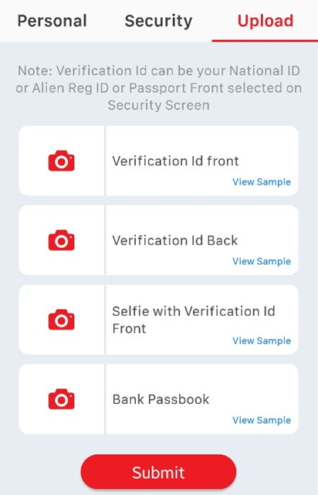

|  |  |
| --- | --- |
| Verification Id front |  |
| Verification Id Back |  |
| Selfie with Verification Id Front | Deletion scheduled |
| Bank Passbook | Deletion scheduled |
| Submit | Sign - up successful once completed.  If the membership is successful, log in is possible. |
|  |  |
|  |  |
|  |  |

# Register-PennyTest

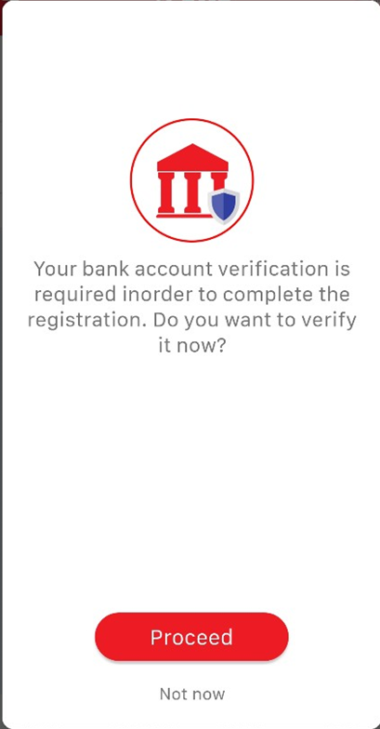

|  |
| --- |
| To the success of the membership, unless the success of pennytest pennytest to run the screen. |